

Department of Computer Science and Engineering

**Jaypee University of Information Technology, Wakhnaghat, Solan, Himachal Pradesh - 173234**

**Topic - License Plate Recognition by Optical Character Recognition(OCR)**

**Submitted By -** Reet Sethi (191222)

Prishita Singh (191223)

**Submitted to -** Dr. Aman Sharma

**TABLE OF CONTENTS**

| **Sr. No.** | **Content** | **Page No.** |
| --- | --- | --- |
| **1.** | **Abstract** | 3 |
| **2.** | **Introduction** | 4 |
| **3.** | **Literature Survey**   1. Existing Approach 2. Related Work | 5 |
| **4.** | **Approach and Working**   1. CNN 2. The model 3. Training 4. Model Loss 5. Testing 6. Text Recognition | 6  6  7  9  11  12  13 |
| **5.** | **Flowchart** | 14 |
| **6.** | **Results**   1. Dataset 2. Final Results | 15  16 |
| **7.** | **Conclusion** | 18 |
| **8.** | **Future Scope**   1. Limitations 2. Future Work | 19  20 |
| **9.** | **Acknowledgments and Citations** | 21 |

**ABSTRACT**

In recent years, deep learning has followed its path of success at a good pace. Convolutional Neural Networks (CNNs) are getting used massively in the field of computer vision and machine learning.

It is very challenging to extract textual components from natural images. However, we have many practical applications for recognizing text in unconstrained images, but the background variations, fonts, lightings, and other factors make the task difficult.

License Plate Recognition is an existing concept with many successful solutions. However, these solutions vary due to various environments across the world. The algorithms written for license plate recognition are based on these variations, and hence, a universal solution would be challenging to develop and analyze.

Our project’s**” License Plate Recognition Using OpenCV ”** algorithm is implemented with Python Programming Language based on Convolutional Neural Networks (CNN). Our project has a better accuracy of recognition.

The CNN is used here to train the dataset of over 200 images of Indian vehicles for detection and segmentation of the license plate. The overall accuracy of the detection model is around 80%. Here, we have used Keras to implement the pre-processing of CNN.

The focus of this application is a proposed algorithm that detects, segments, and recognizes Indian vehicle license plates. Our resulting model is simple, accurate, and fast, allowing it to be used at scale on a variety of challenging real-world text extraction problems.

Our application inputs an image of a with a visible license plate. The CNN training model detects the plate and returns a text (license plate number) as an output.

**INTRODUCTION**

License Plate Recognition is a tremendous benefit for traffic, parking, and toll management systems.

Let’s consider a real-life problem, traffic signal rules violations.

Our application would help to recognize the license plate of the camera captured vehicle that violates the rules. This license plate number would identify the owner and could be punished.

The vehicle can be identified with a license plate with no additional information required. With a drastic increase in the number of transportation, it is becoming challenging to handle the different incidents related to the vehicles.

This License plate recognition application can ease the problems and ensure better services for traffic monitoring, automatic parking management systems, or license plate expiration date detection.

Optical character recognition (OCR) is a way of detecting, segmenting, and recognizing the text from any piece of the picture. The main aim of OCR is to convert the text in an image to machine-encoded text.

The algorithm is written in Python language using the OpenCV library. It can also be used to recognize the standard text of any image. We have used libraries like Matplotlib, OpenCV, NumPy for obtaining the desired results. We have used a free OCR API service that helps in recognition. We took this OCR API service from ocr.space [1].

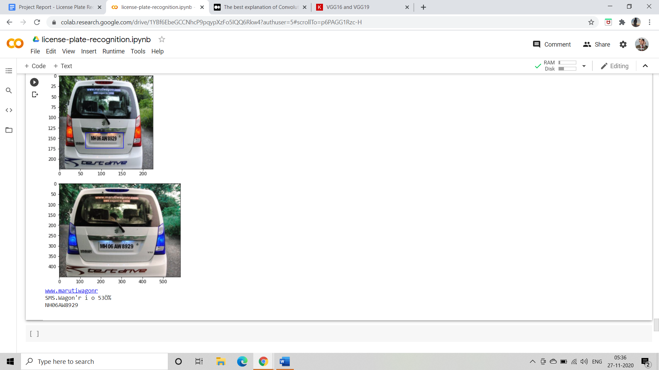 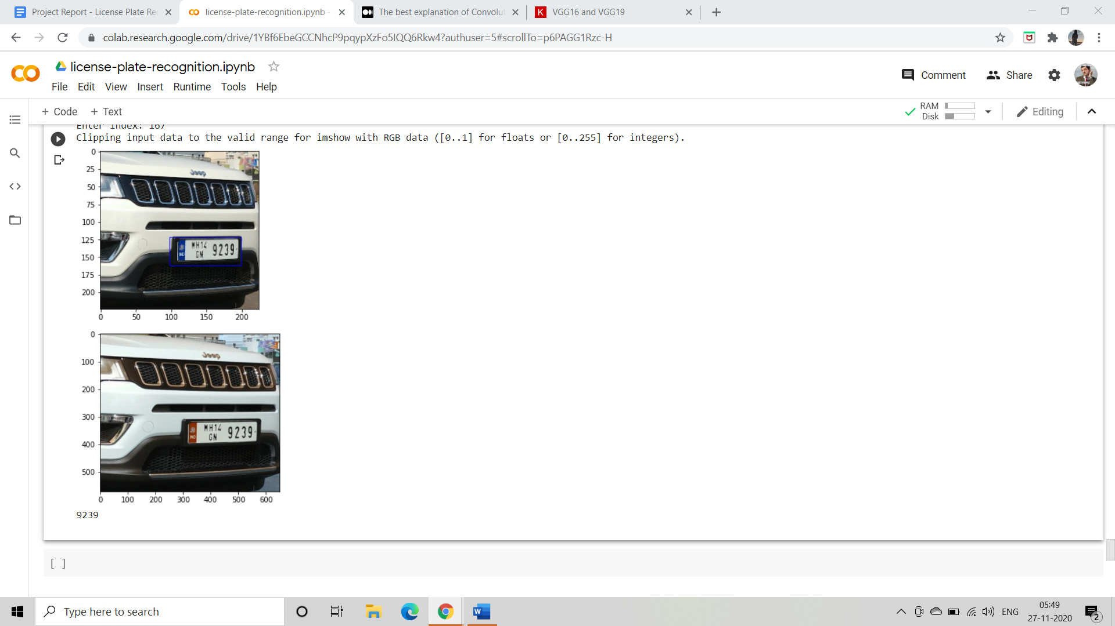

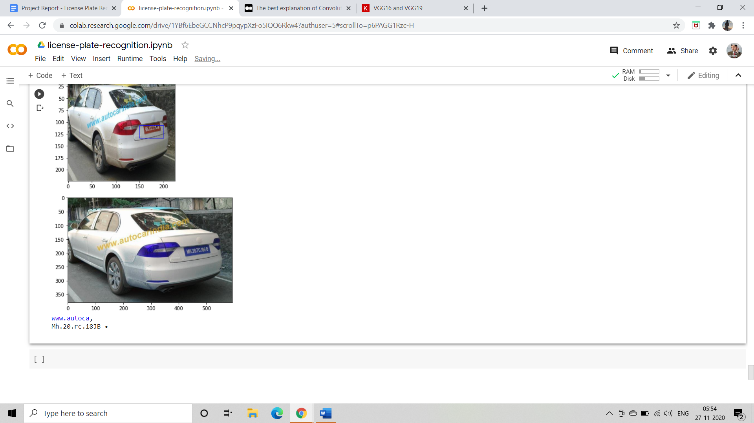 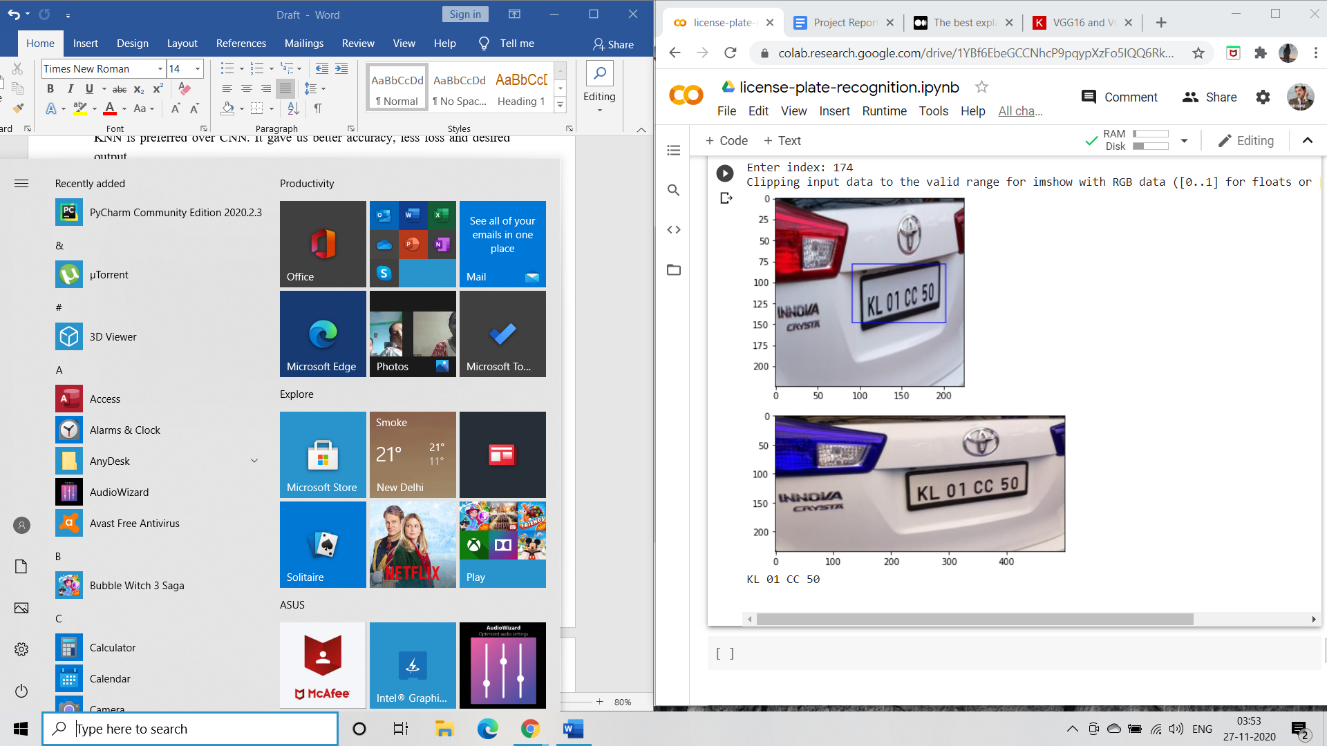

The entire application involves different parts that include: making changes in the dataset according to the requirement, pre-processing, training, and recognition.

**LITERATURE SURVEY**

**Existing System:**

We have incidents like traffic signal violations where the vehicle gets the privilege to run away. But with our approach, this would be easier to catch the violator. Other systems that are designed are implemented on the CNN model for detection and the OCR algorithm for recognition.

**Related Work:**

There are many working systems for license plate recognition with certain drawbacks and accuracy of the results. We have systems that will detect the plate but not the text. Some projects detect text without using a model, just by using OpenCV and tesseract.

**APPROACH AND WORKING**

There are three main steps considered in the code. The first one is getting the data from the given JSON file. The second one is creating a usable CSV from it. And the third one is creating and training a deep CNN for license plate detection. We used Keras to make the CNN part simpler.

After importing all the libraries required, we get into the working of the project.

Our dataset which is in the form of a .json file is first accessed. Python Language has a built-in module for JSON files. The .json file is then converted to a dataset using the pandas library in python. Since the images are in the form of URLs in the created data frame and cannot be accessed directly from there.

An unstable CSV file is created from the .json file to ease access to the images of the dataset. The informations that we recorded in the .csv file from the .json file are - image_width, image_height, x and y coordinates of top left corner and x and y coordinates of bottom right corner of the bounding box ([top_x, top_y, bottom_x, bottom_y]).

At first, we assumed that all the images are of the JPEG format. However, a quick inspection of the dataset showed that this assumption was wrong. Some of the images are in the GIF format. So, before saving the images, they are converted to the JPEG format images with three (RGB) channels by using the **PIL.Image** module.

We then split the data into two with a batch size of 32 images. One for training (80% of the data) and one for validation/testing (20% of the data) during training. Testing is important to see if the model overfits the training data.

**CNN**

CNN (Convolution Neural Network) is a type of neural network model which allows us to extract higher representations for the image content. Unlike classical image recognition where you define the image features yourself, CNN takes the image’s raw pixel data, trains the model, then extracts the features automatically for better classification.

The idea is that you give the computer this array of numbers and it will output numbers that describe the probability of the image being a certain class. The computer performs image classification by looking for low-level features such as edges and curves and then building up to more abstract concepts through a series of convolutional layers. The computer uses low-level features obtained at the initial levels to generate high-level features.

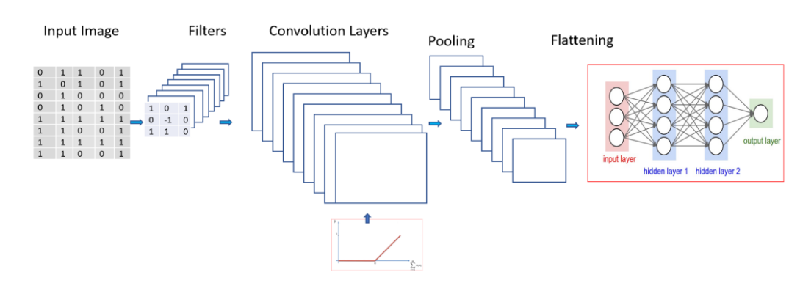

**The Model**

We created a convolutional neural network having 8 convolutional layers with 4 max pool layers and a fully connected network with 2 hidden layers.

A Sequential model is appropriate for a plain stack of layers where each layer has exactly one input tensor and one output tensor. We created a sequential convolution model with 6 layers.

In sequential convolution layers when we go through a Conv. layer, the output of the first Conv. layer becomes the input of the 2nd Conv. Layer.

However, when we reach the 2nd Conv. layer, the input is the activation map(s) that result from the first layer. So each layer of the input basically describes the locations in the original image for where certain low-level features appear.

Now when you apply a set of filters on top of that (pass it through the 2nd conv. layer), the output will be activations that represent higher-level features. Types of these features could be semicircles (a combination of a curve and straight edge) or squares (a combination of several straight edges).

As you go through the network and go through more conv. layers, you get activation maps that represent more and more complex features. By the end of the network, you may have some filters that activate when there are letters in the image.

Here is the snippet of our code for reference.

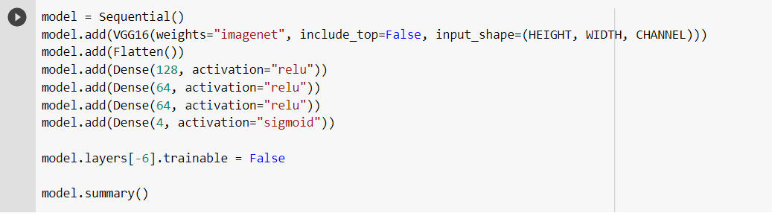

The model has the following layers:

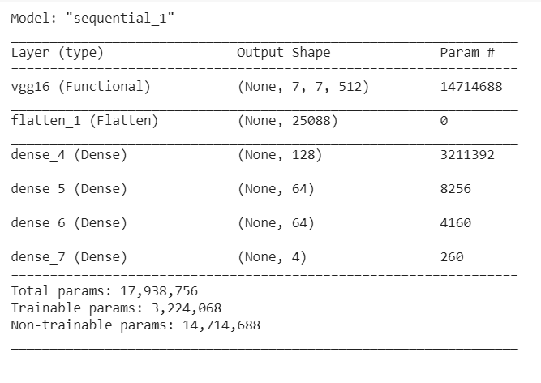

The model is then trained using stochastic gradient descent and requires an appropriate loss function when designing and configuring your model. There are many loss functions to choose from or even what a loss function is and the role it plays when training a neural network. The Adam loss function is used here, to optimize the weights and mean squared error.

**The Adam Optimiser**

Adam is an adaptive learning rate method, which means it computes individual learning rates for different parameters. Its name is derived from adaptive [moment](https://en.wikipedia.org/wiki/Moment_(mathematics)) estimation, and the reason it’s called that is that Adam uses estimations of first and second moments of the gradient to adapt the learning rate for each weight of the neural network. The N-th moment of a random variable is defined as the [expected value](https://en.wikipedia.org/wiki/Expected_value) of that variable to the power of n. More formally:

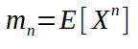

Where, m — moment, X -random variable.

Adam to optimize the weights and mean squared error as our loss function.



**Training**

The Keras deep learning library includes three separate functions that can be used to train your own models: *.fit, .fit_generator, .train_on_batch*. All three of these functions accomplish the same task, but each follows a different method of doing it. In our model, we have used *.fit_generator*.

The .fit_generator function accepts the batch of data, performs backpropagation, and updates the weights in our model. This process is repeated until we have reached the desired number of epochs.

The Keras data generator is meant to loop *infinitely* — it should *never* return or exit. Since the function is intended to loop infinitely, Keras has no ability to determine when *one epoch starts* and a *new epoch begins*. Therefore, we compute the steps_per_epoch value as the total number of training data points divided by the batch size. Once Keras hits this step count it knows that it’s a new epoch.

*Step Size (steps_per_epoch) = Number of elements / Batch Size*

In our case, the Number of elements = 232

Batch Size = 32

Step Size = 7.2 (approx 7)

Here is the extract from the code that we’ve used to train our dataset.

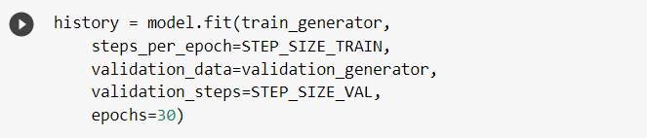

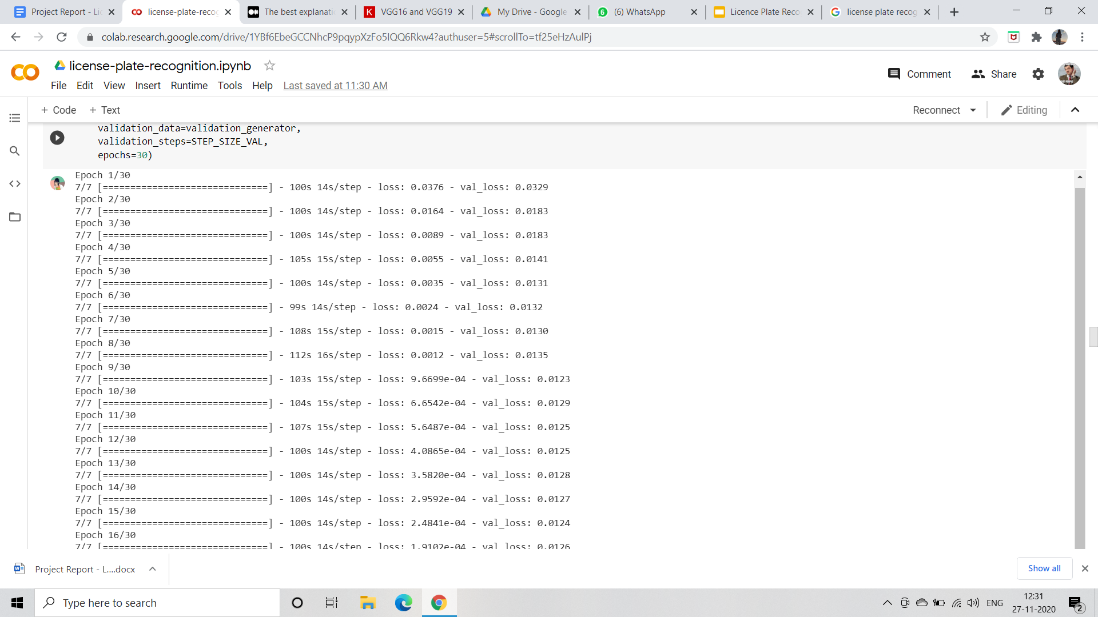

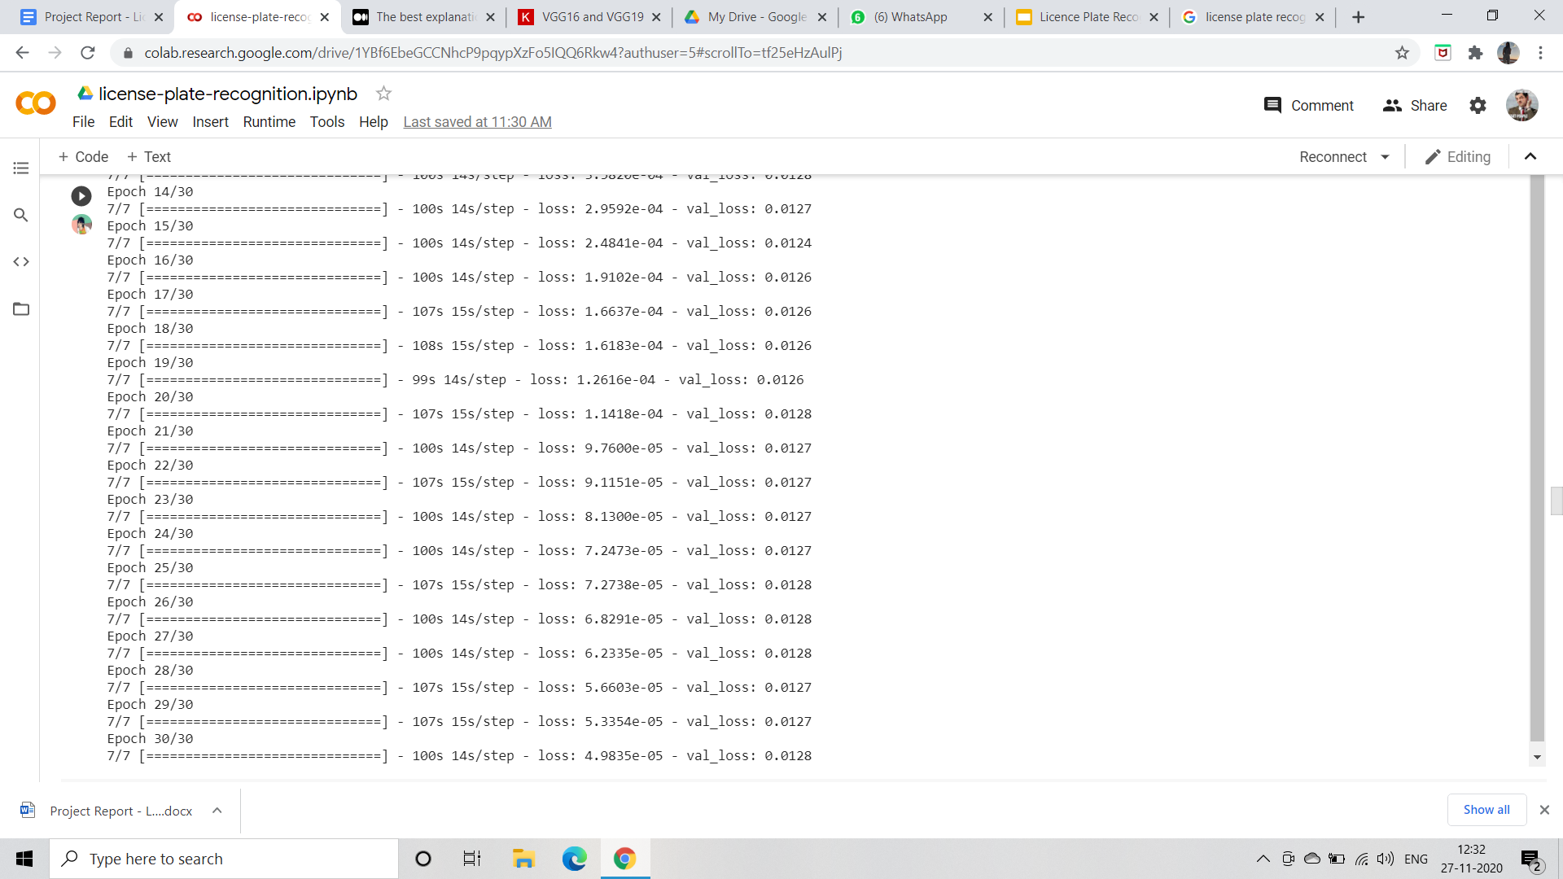

**Model Loss**

The model's success over the validation data is almost 80%. However, we can see that from the above figure, the training has stopped after the 30th epoch. This may occur because of the low number of training samples, or my model is not capable of learning such data.

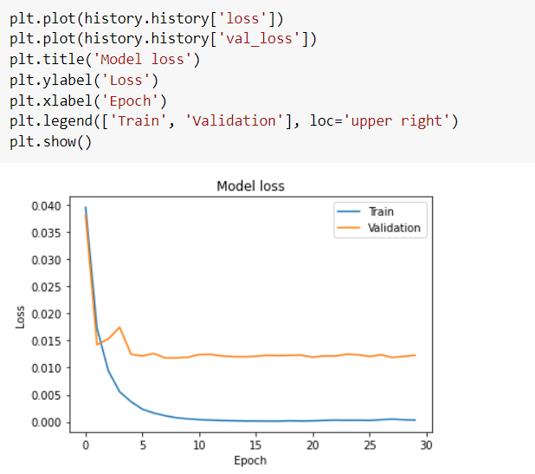

**Testing**

The remaining 20% of the dataset undergoes testing

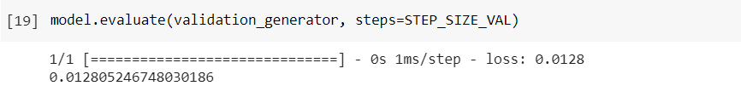

The detected license plates were as follows:

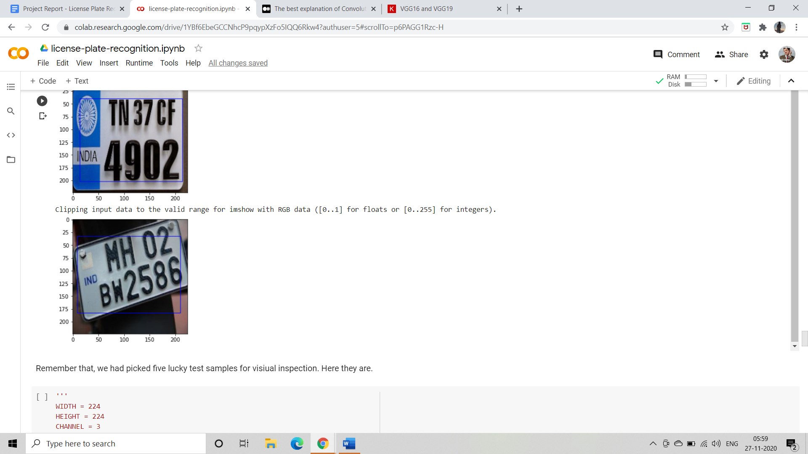 

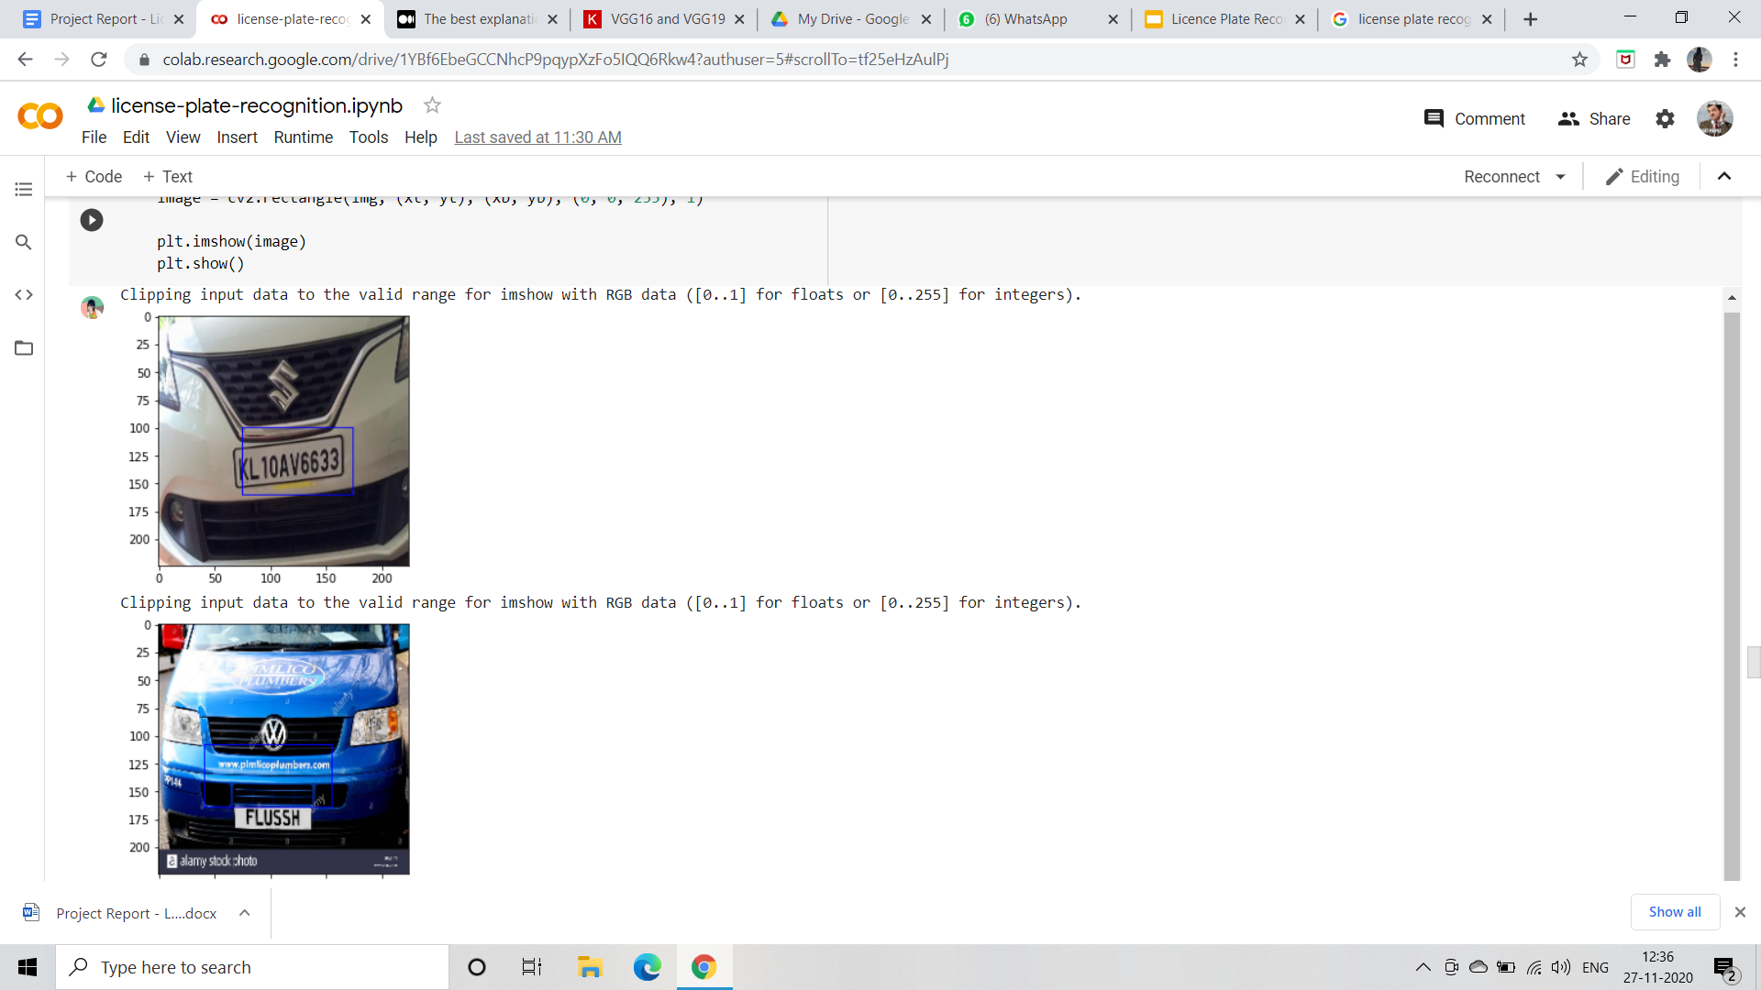 

**Text Recognition using OCR API**

A simple and basic approach is applied to recognize the text on the license plate. A glimpse of the code is here:

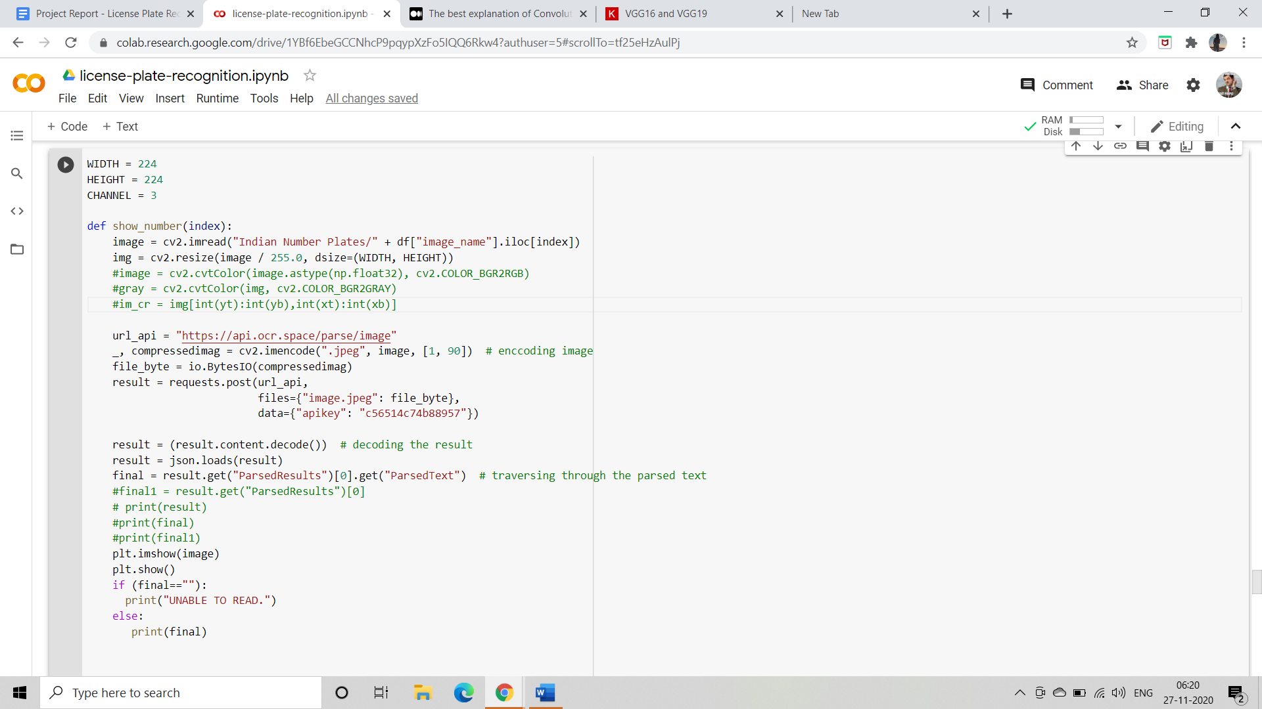

The basic concept is that a request is sent to the API using a request .post() and an API-key which when receives the request i.e. an encoded image, processes the encoded image and returns the encoded result. This encoded result is decoded. The json.loads() method is used to make it easier to parse the results. Now we are with our desired results.

Have a look at the flow of the algorithm.

**FLOWCHART:**

**Here is the basic pipeline of our project**



This is the flow of the basic algorithm we used to detect and recognize the license plate from a natural image in our dataset. Since our dataset was in .json format, here the Image dataset refers to the dataset converted to .csv format.

**RESULTS**

**Dataset**

To evaluate the results and performance of the CNN, we tested random images of our own dataset. Our data set contains 237 images in total. We used 80 percent of them for training and 20 percent for validation. Our data set is a JSON file that includes multiple lines of record in it. The two main elements are *content,* which contains the link of the image with .jpeg extension and *annotation,* that contains the image height, width, and other required information about the image. Our dataset in .json format looks like:

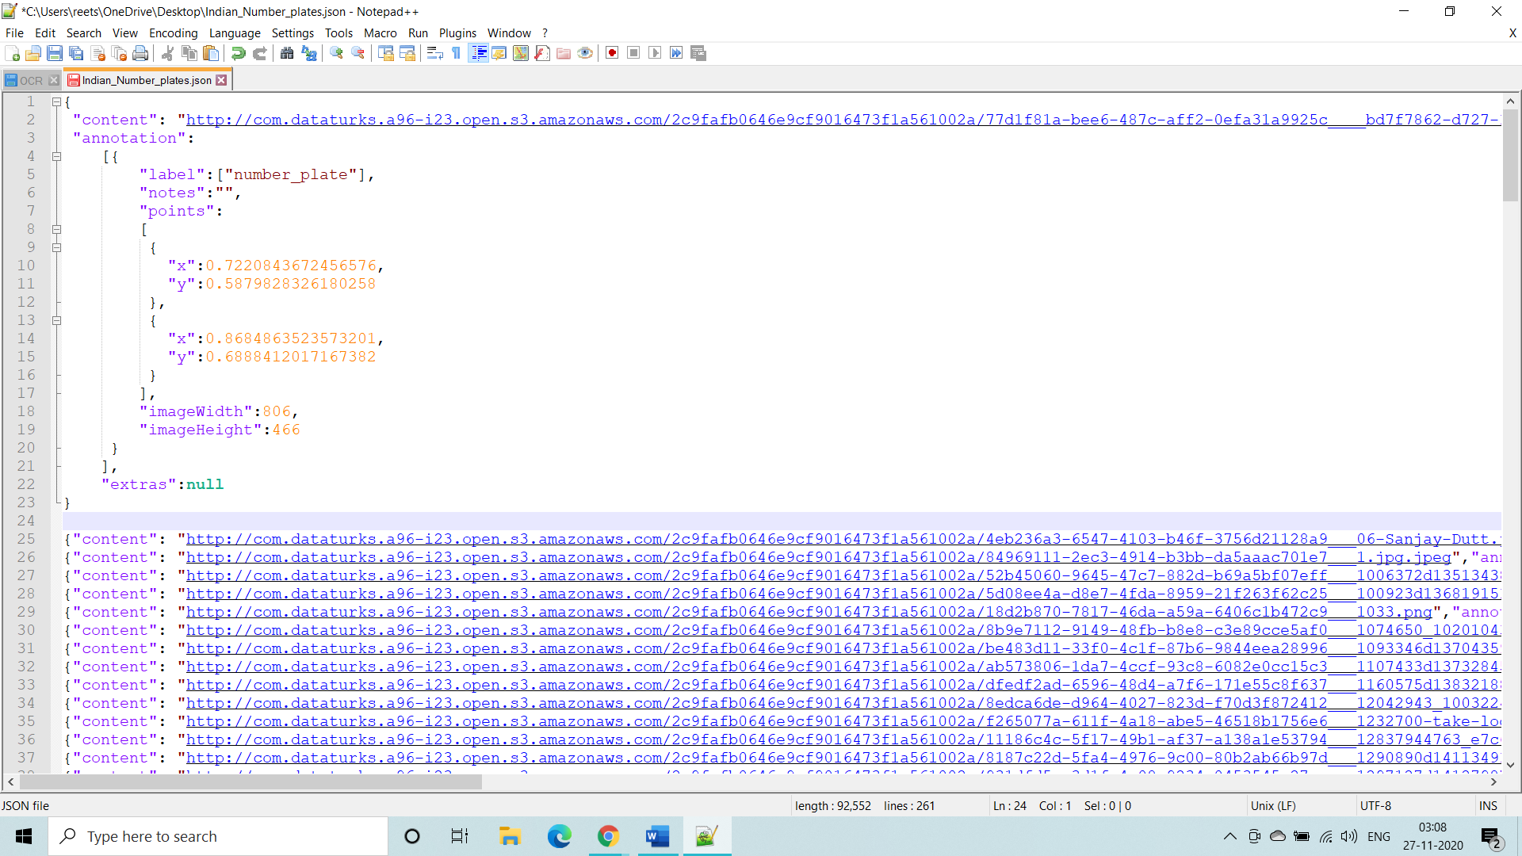

We then converted the dataset to a CSV file according to the requirement of the image annotations. This CSV data looks like:

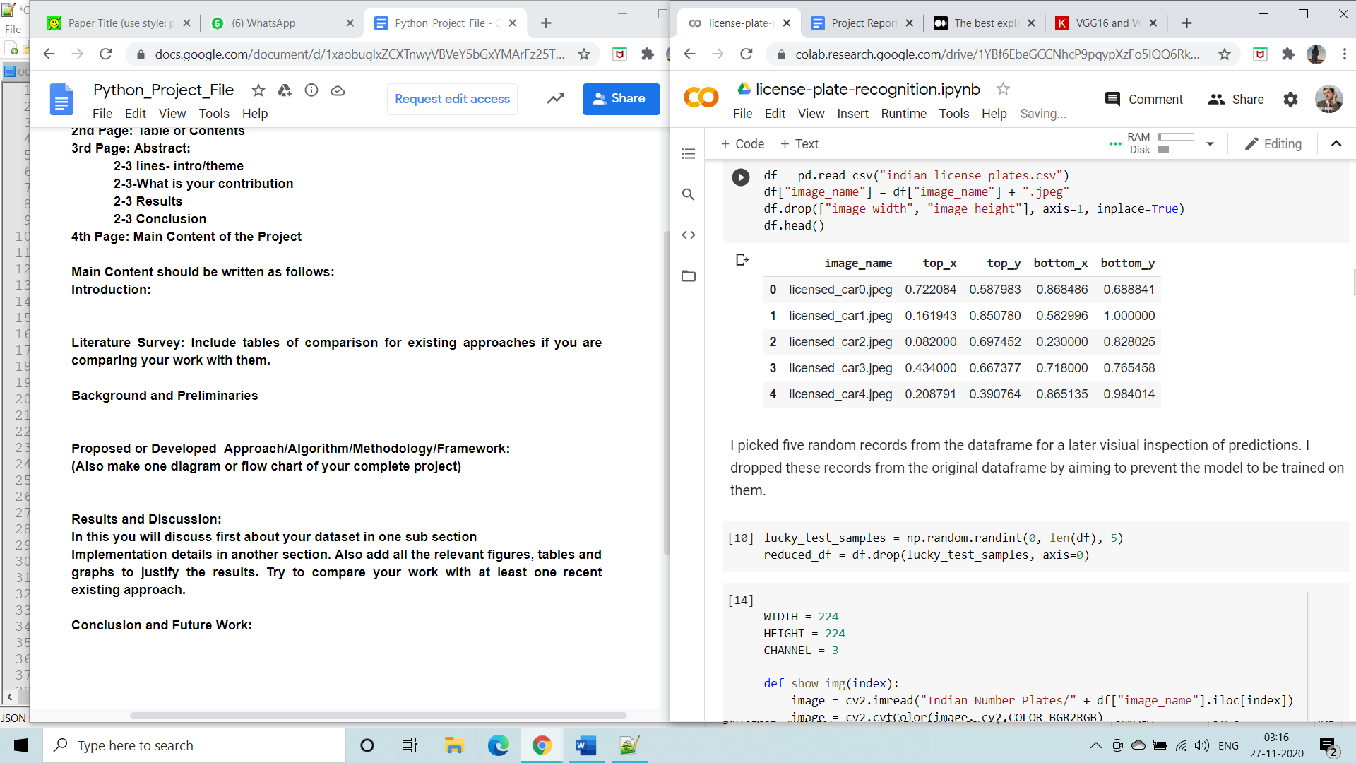

**Final Results**

After changing the dataset according to the convenience and requirements, the dataset undergoes a CNN training model for detecting the license plate. After training, an image is input from the dataset, and using the OCR API key, we got our desired results that were as follows:

| **S**  **No.** | **The Original image from the dataset** | **The detected license plate after training** | **Result** |
| --- | --- | --- | --- |
| 1. |  |  | KL 01 CC 50 |
| 2. |  |  | KL IOAW2814 |
| 3. |  |  | 0MHUDW8351 |
| 4. |  |  | GJW.1-15.A.1138 |
| 5. |  |  | MH12JC2813 |

Table - showing the obtained result after training, testing the CNN model and recognising the characters of the number plate.

**CONCLUSION**

We had an image of a vehicle with a visible license plate. We pre-processed the CNN model for the detection of the license plates. The detection was followed by an OCR API that receives a request through an API-key and returns back the recognized text. The present proposed algorithm detects the license plate of a vehicle and returns the number as the output. But these images are captured when the vehicle was still. In some images where the license plate was at an angle or there was a lot of noise in the image, the OCR API was not able to read the text. Some of the cases are:

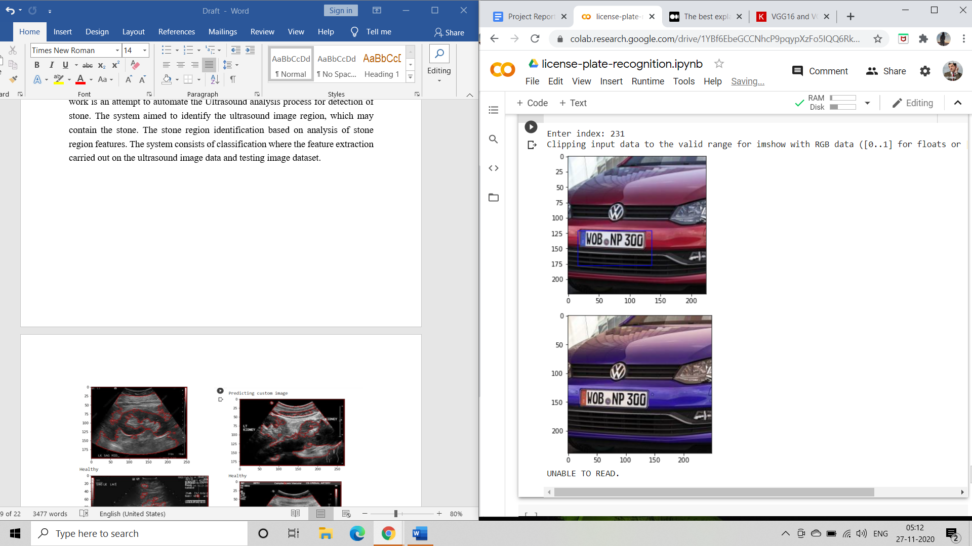 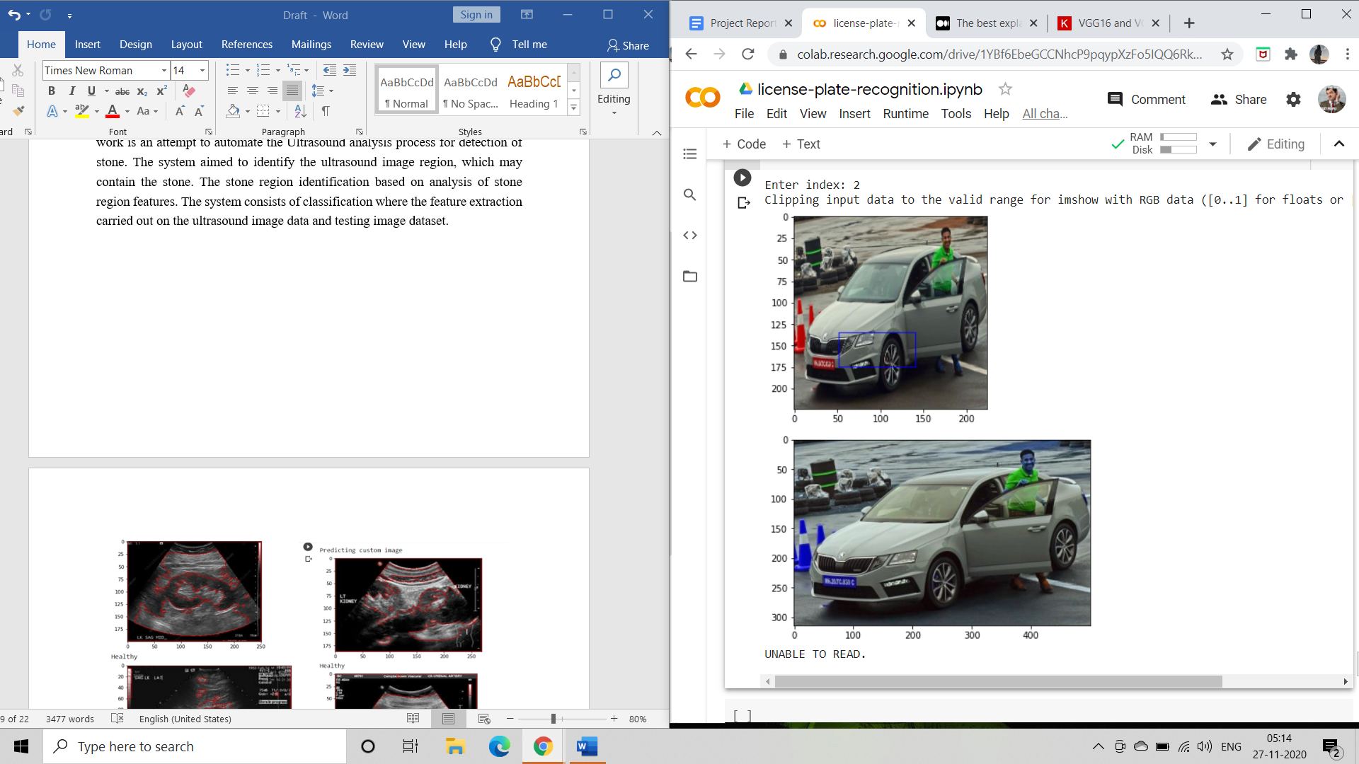

The CNN detection used to detect the license plate in the images. It has an overall accuracy of 60% - 80%. The accuracy of detection can be enhanced by using more layers from the Keras open source library.

The model defined above is a very simple toy model. The training is straightforward and tests may not be reliable since the dataset is so small. However, it proves a concept that you can find plates from images with a simple CNN. This network may be used as a part of other more complicated networks.

**FUTURE SCOPE**

**Limitations**

Every model has its limitations. The limitations of our proposed model are as follows -

* Since our model uses OCR API to detect the text in the image, it detects almost every character that is recognizable. Due to this sometimes there are extra characters in the output. This can be avoided by further optimization of the API part of the code.
* The dataset considered here has only 200+ images of different license plates from different angles. A larger dataset needs to be considered for training and testing to be more accurate. Also, the images of moving vehicles are not a part of the dataset.
* The accuracy of the model is satisfactory, but not good and can be improved with further work. Incomplete text recognition is observed in a few images. Here is an example:

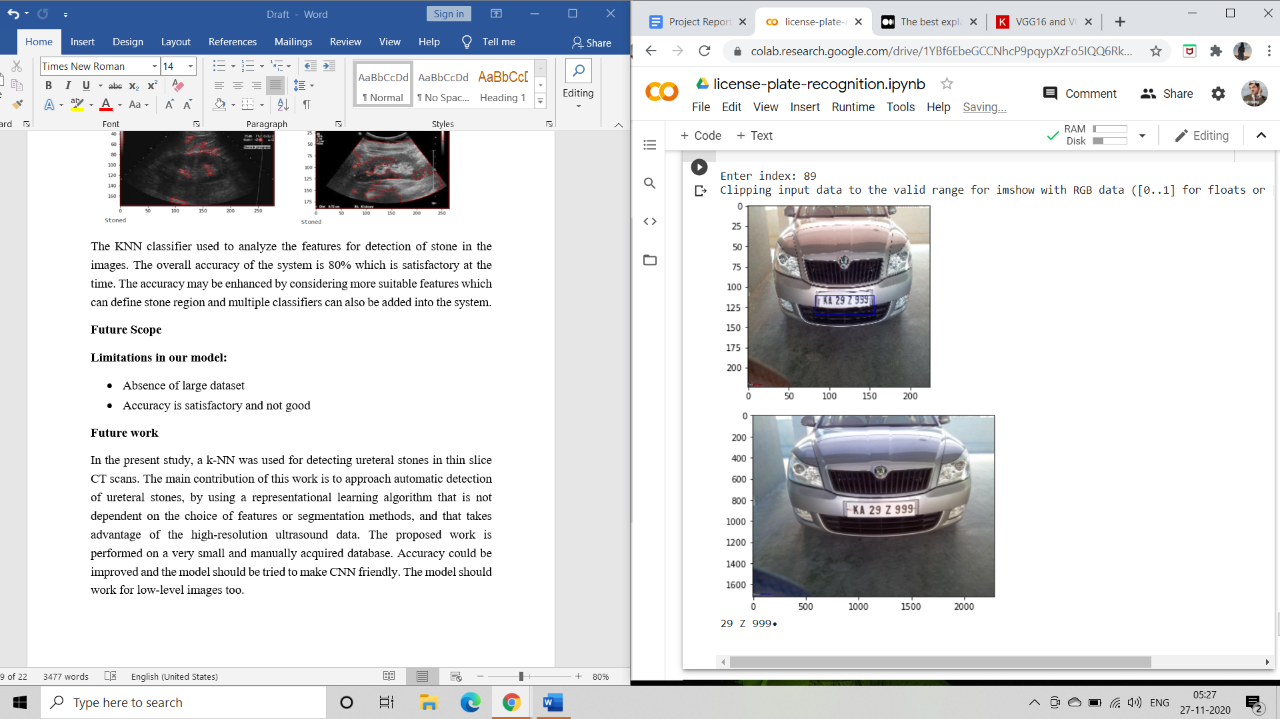

**Future Work**

The current model can be refined further to work with the dataset of images that are captured while the vehicle is moving. The OCR API conditions can be improved for accurate detection for detecting only the license plate. The dataset can include images from different countries or can be adapted to a particular country for more results.

People tend to forget license plates or sometimes don’t even notice them. This can be a problem in hit and run cases, chain snatching cases, acid attack cases and many more. So by further improving the project we can use the images to find the vehicles with the help of license plate and the model of the vehicle.

We can even combine the recognised vehicle plates with people making it easier to reach them and find their details. If implemented correctly this can be very useful for the police force.

**ACKNOWLEDGMENTS**

We referred to the work of the following authors:

* <https://arxiv.org/ftp/arxiv/papers/1809/1809.00905.pdf>
* <https://www.researchgate.net/profile/Andrew_Agbemenu/publication/325223548_An_Automatic_Number_Plate_Recognition_System_using_OpenCV_and_Tesseract_OCR_Engine/links/5c87e7ea299bf14e7e781750/An-Automatic-Number-Plate-Recognition-System-using-OpenCV-and-Tesseract-OCR-Engine.pdf>
* <https://ai.stanford.edu/~ang/papers/ICPR12-TextRecognitionConvNeuralNets.pdf>

**CITATIONS**

1. <http://ocr.space/OCRAPI>
2. <https://medium.com/technologymadeeasy/the-best-explanation-of-convolutional-neural-networks-on-the-internet-fbb8b1ad5df8>
3. <https://keras.io/api/applications/vgg/>
4. <https://www.geeksforgeeks.org/cnn-image-data-pre-processing-with-generators/>
5. <https://meet.google.com/eye-indt-tez>